Assignment 8

In Assignment 8, you will use concepts from the PowerPoint slides in Week 9.

Please make sure to put all answers into a single PDF or Word/RTF document. Do not submit as separate files please. In the document, include all steps as I have listed here. For each T-SQL programming step or action, show your code/step as well as a screenshot of the results when you complete the action (if applicable).

- Use the bcp command utility to create a text file called Categories.txt that contains the exported data from the NorthWnd.dbo.Categories table. Open your file created from this step in a text editor and inspect it. Submit a screenshot of your bcp command as executed in the command prompt and the outcome.
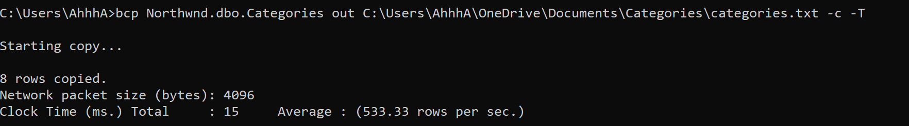

- Create a database called test. This can be done with your GUI tools in SQL Server Management Studio or with code.
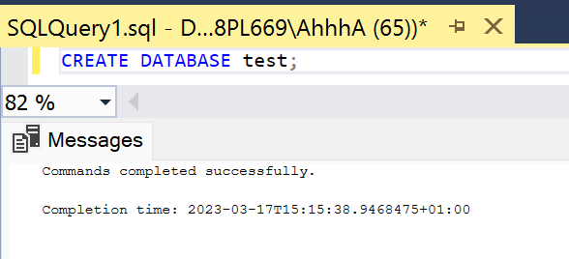

- In the test database create a schema called Production. This can be done with your GUI tools in SQL Server Management Studio or with code.
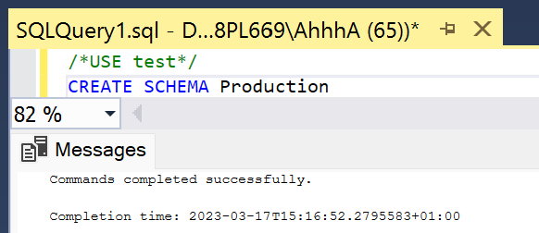

4.) Create a table ‘Production.Categories’ in the test database. Use T-SQL code for this step.

- Note that Categories should be in the Production schema (not default schema of dbo). Recall to create a table within a certain schema, the schema name must be prefixed to the front of the table name in your CREATE TABLE statement, such as Production.Categories.

- Create the table to have the following columns, data types, and constraints.
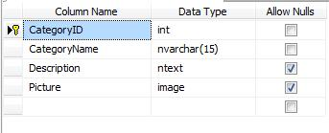
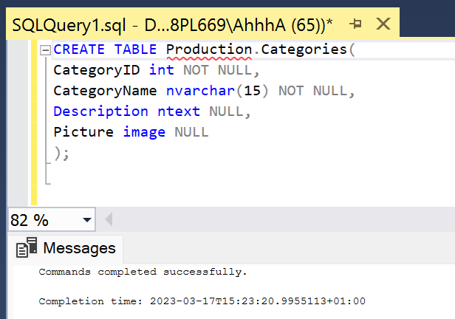

5.) Create a BULK INSERT statement that will import the data from Categories.txt (Step 1 above) into the Production.Categories table created in Step 4 above. In your screenshot show both your code and the result. Remember that BULK INSERT is T-SQL code and therefore is executed in a query window in Management Studio unlike the bcp command.

BULK INSERT
test.Production.Categories
FROM 'C:\Users\AhhhA\OneDrive\Documents\Categories\categories.txt'
WITH (datafiletype='native');

6.) For this next part, use the Import/Export Wizard inside of Management Studio. Import the table data from the NorthWnd.dbo.Customers table into a Production.Customers table in your test database. Note how the table structure as well as the data can be copied using the wizard.

- Hint: When using the wizard, make sure when selecting the source and destination table, that you click in the destination table name and change it from the default “dbo” schema to “Production” as the schema name.

- For this step, submit a screenshot like that below that shows a query against the Production.Customers table and shows the results.

